ExNo:19 //CHECKING –NON EMPTY

PROGRAM:

<html>

<head>

<script>

function validateForm() {

var x = document.forms["myForm"]["fname"].value;

if (x == "")

{

alert("Name must be filled here");

return false;

}

}

</script>

</head>

<body>

<center>

<form name="myForm"onsubmit="return validateForm()" >

Name: <input type="text" name="fname" placeholder="enter your name">

<input type="submit" value="Submit">

</form>

</center>

</body>

</html>

OUTPUT:

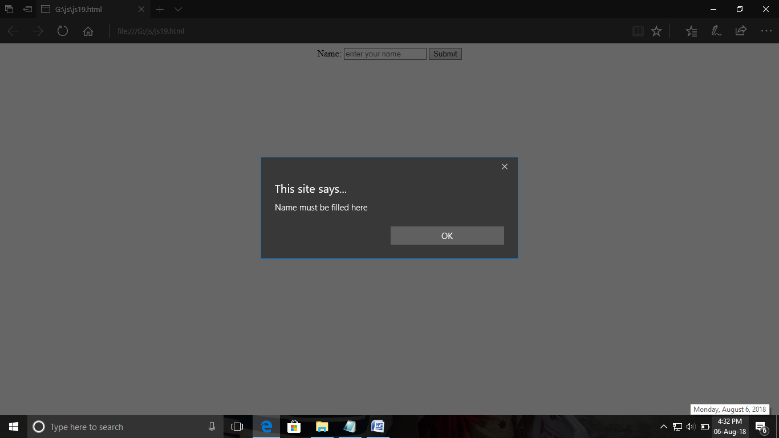

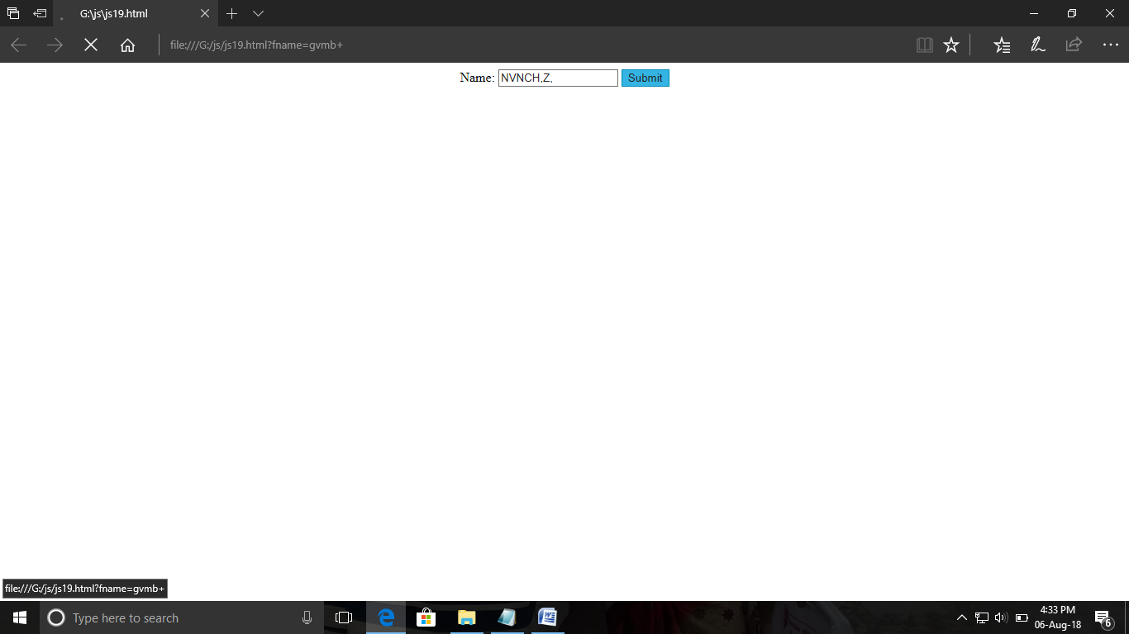

ExNo:20 //CHECKING-ALL NUMBER

PROGRAM:

<html>

<head>

<script>

function validateForm() {

var x = document.forms["myForm"].value;

if (x == "")

{

alert("number must be fill here");

return false;

}

}

</script>

</head>

<body>

<center>

<form name="myForm"onsubmit="return validateForm()" >

Name: <input type="number" name="fname" placeholder="enter number here">

<input type="submit" value="Submit">

</form>

</center>

</body>

</html>

OUTPUT:

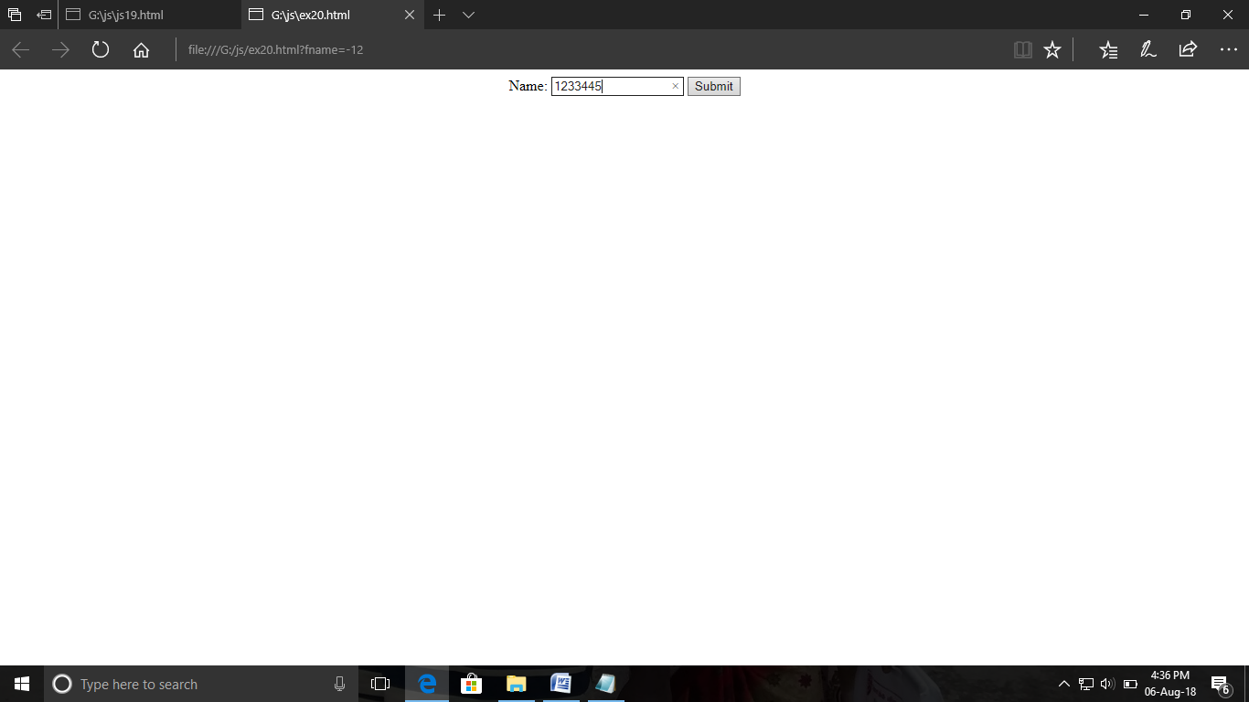

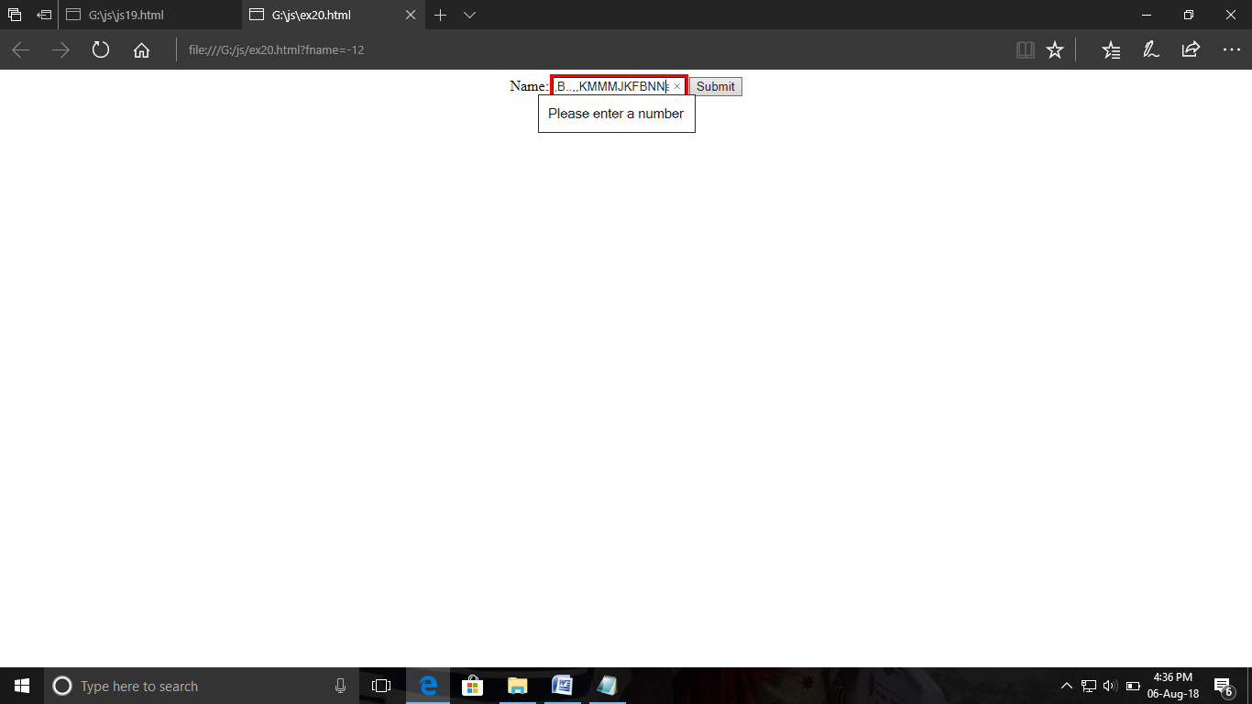

ExNo:21 //CHECKING-ALL LETTER

PROGRAM:

<html>

<head>

<title>Letter Check</title>

</head>

<body>

<p>ENTER HERE:</p>

<input id="din">

<button type="button" onclick="myFunction()">Submit</button>

<script>

function myFunction() {

var x, text;

// Get the value of the input field with id="din"

x = document.getElementById("din").value;

if (!x.match(/^[a-zA-Z]+$/)) {

text = "Input Only Alphabetzs";

} else {

text = "Input Success";

}

alert(text);

}

</script>

</body>

</html>

OUTPUT:

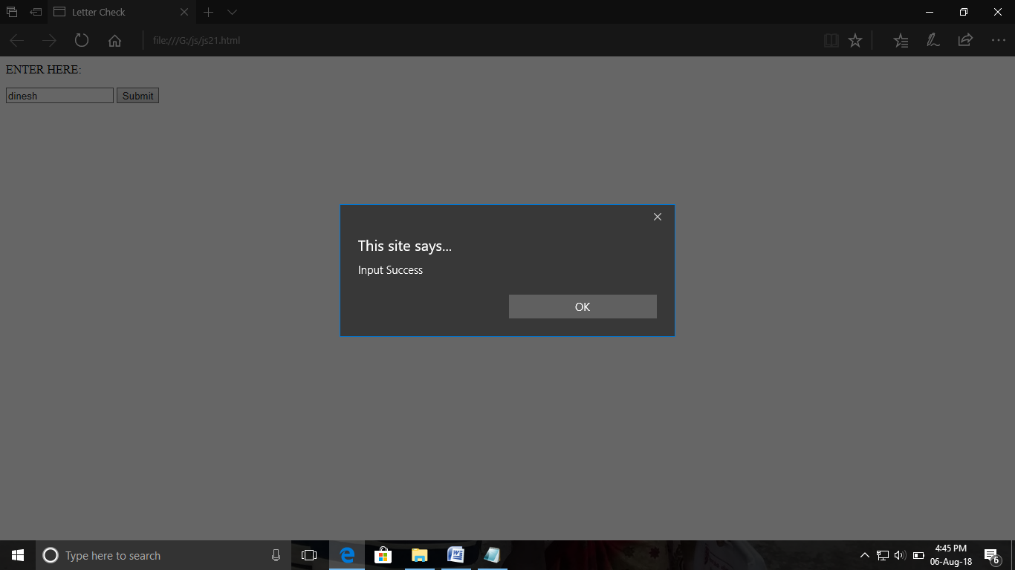

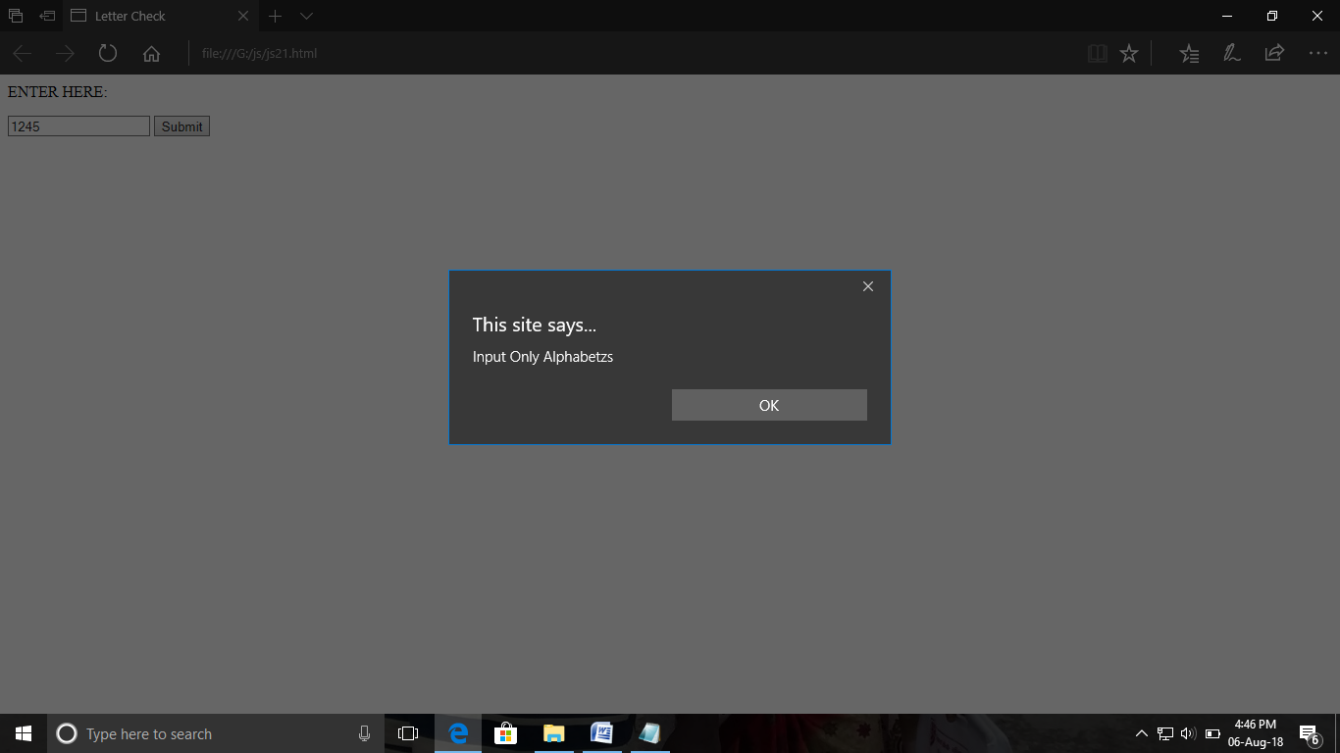

ExNo:22 //CHECKING-ALL LETTER AND NUMBER

PROGRAM:

<html>

<head>

<title>Alphabet Check</title>

</head>

<body>

<p>ENTER HERE:</p>

<input id="din">

<button type="button" onclick="myFunction()">Submit</button>

<script>

function myFunction() {

var x, text;

// Get the value of the input field with id="din"

x = document.getElementById("din").value;

if (!x.match(/^[a-zA-Z0-9]+$/)) {

text = "Input Are Number And Alphabetzs";

} else {

text = "Input OK";

}

alert(text);

}

</script>

</body>

</html>

OUTPUT:

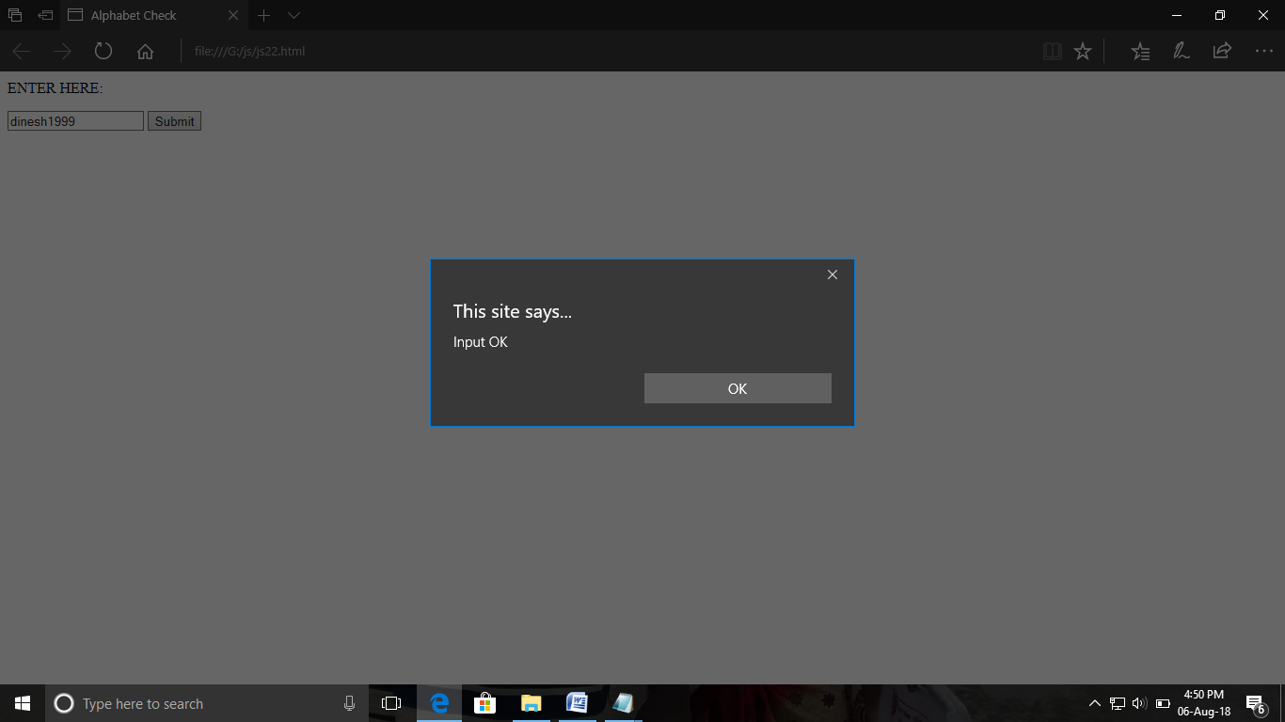

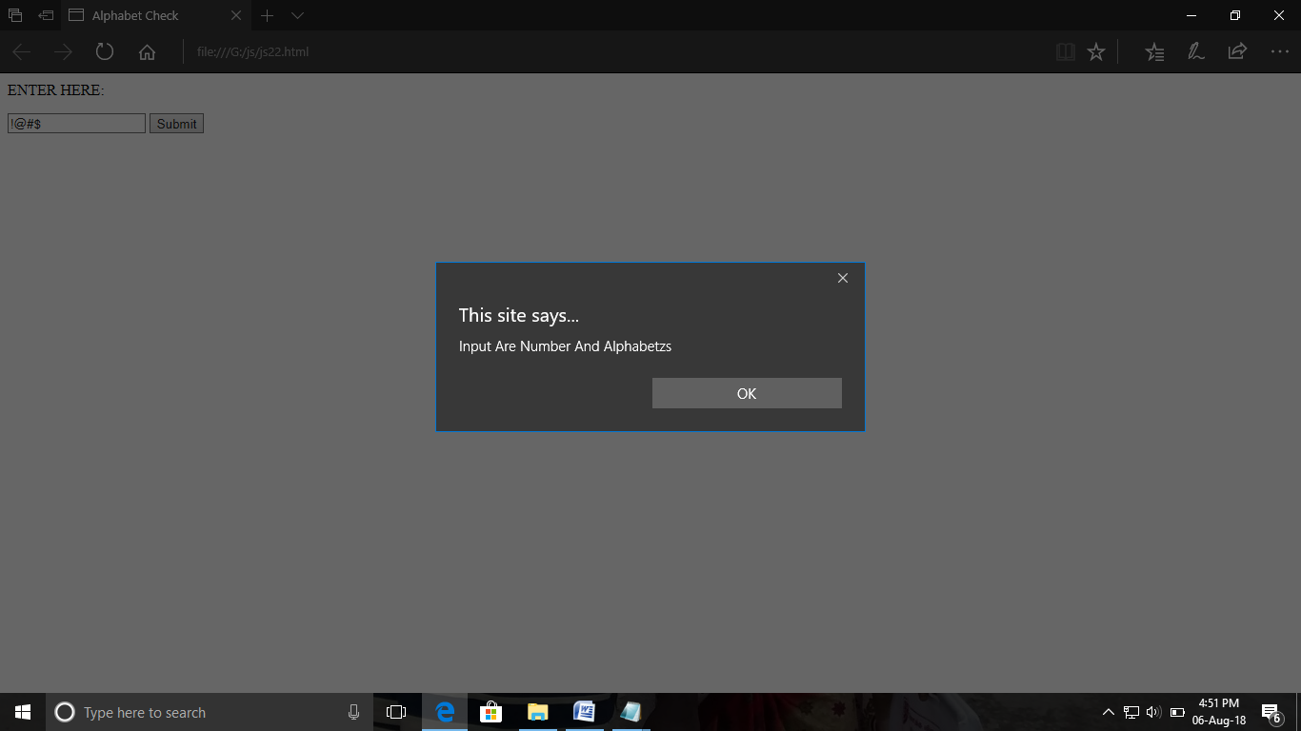

ExNo:23 //CHECK-LENGTH RESTRICTION

PROGRAM:

<html>

<head>

<title>Length Check</title>

</head>

<body>

<p>Enter Here:</p>

<input id="din">

<button type="button" onclick="myFunction()">Submit</button>

<script>

function myFunction() {

var D, text;

// Get the value of the input field with id="din"

D = document.getElementById("din").value;

if (D.length>10) {

text = "Input is too large";

} else {

text = "Input OK";

}

alert(text);

}

</script>

</body>

</html>

OUTPUT:

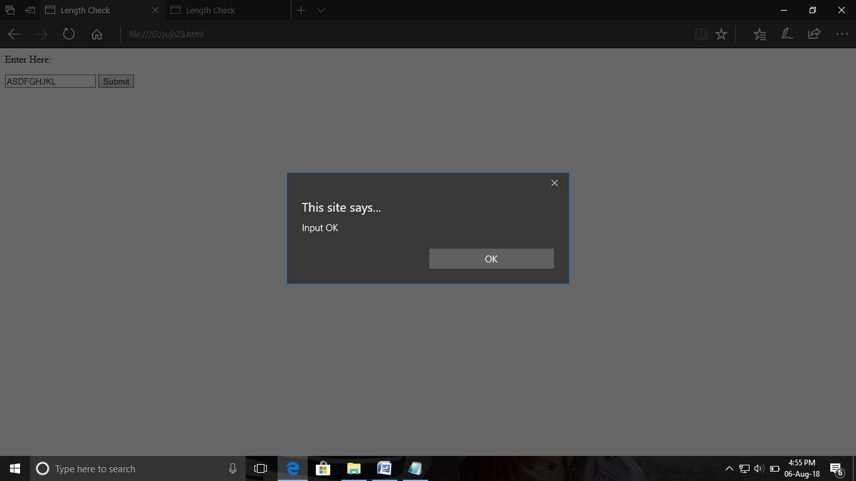

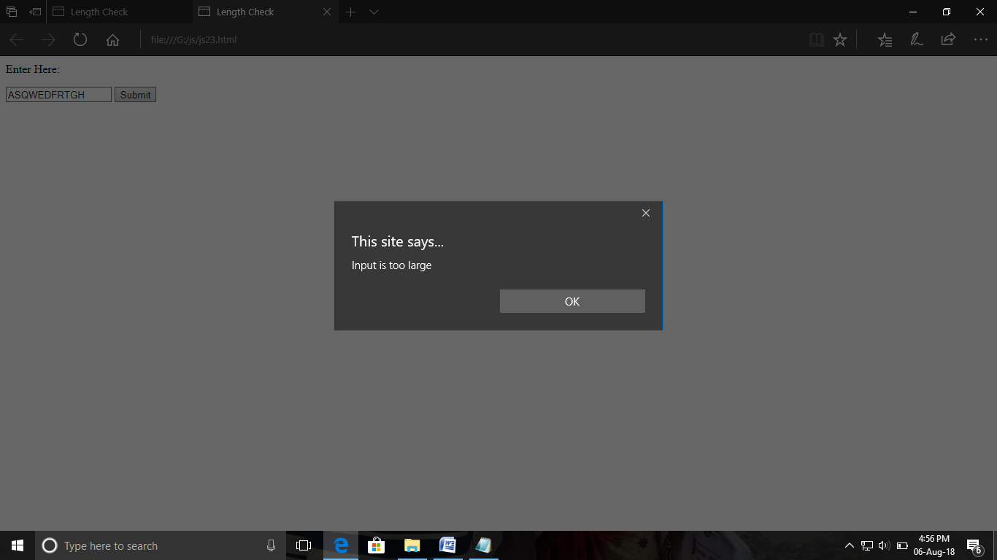

ExNo:24 //CHECK-SELECTION MODE

PROGRAM:

<html>

<head>

<title>Selection Mode</title>

</head>

<body>

<p>Select your native:</p>

<select id="count">

<option value="----">----</option>

<option value="madurai">madurai</option>

<option value="chennai">chennai</option>

<option value="pondichiry">pondichiry</option>

</select><br>

<button onclick="mycontry()">Submit</button>

<script>

function mycontry(){

var m=document.getElementById("count").value;

if(m =="----"){alert("Please select a option")}

else{ alert("OK")}

}

</script>

</body>

</html>

OUTPUT:

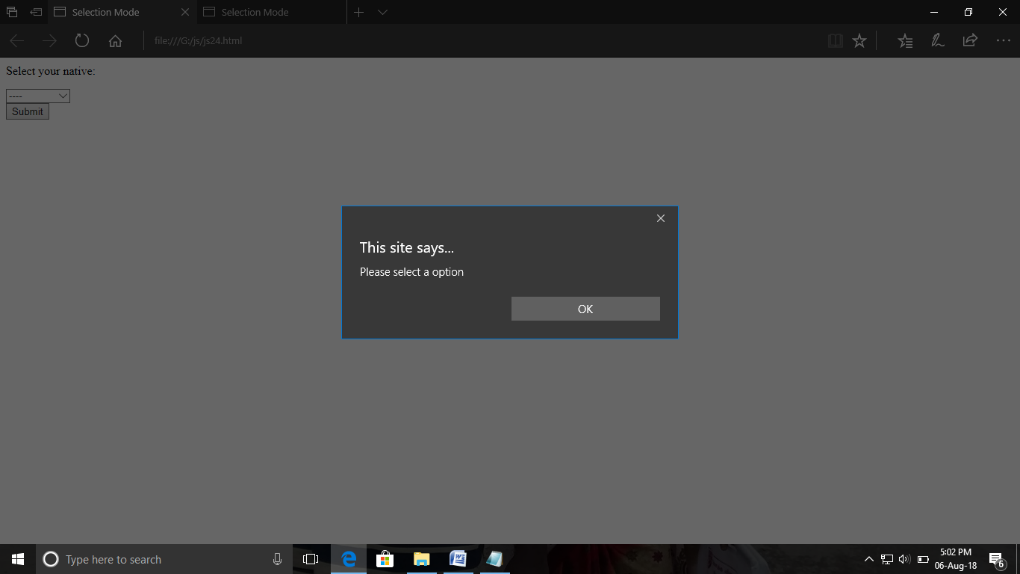

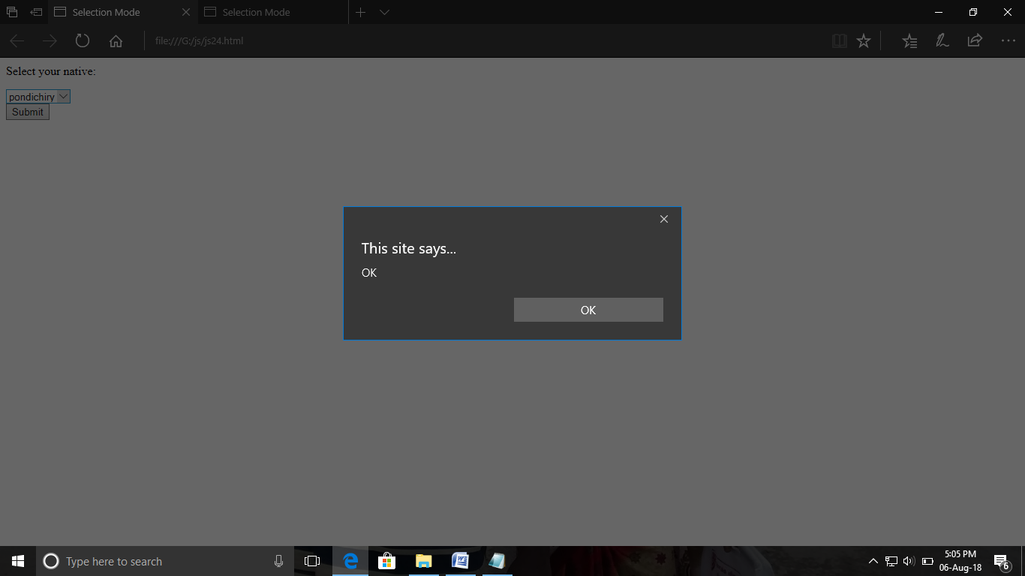

ExNo:25 //CHECK-EMAIL

PROGRAM:

<html>

<head>

<title>E-mail Validation</title>

<script>

function validateForm() {

var x = document.forms["form"]["email"].value;

var at = x.indexOf("@");

var dot = x.lastIndexOf(".");

if (at<1 || dot<at+2 || dot+2>=x.length) {

alert("Please enter a valid e-mail address");

}

else{alert("Successfully logged in");}

}

</script>

</head>

<body>

<form name="form" >

Email: <input type="text" name="email">

<button onclick="validateForm()">CHECK</button>

</form>

</body>

</html>

OUTPUT:

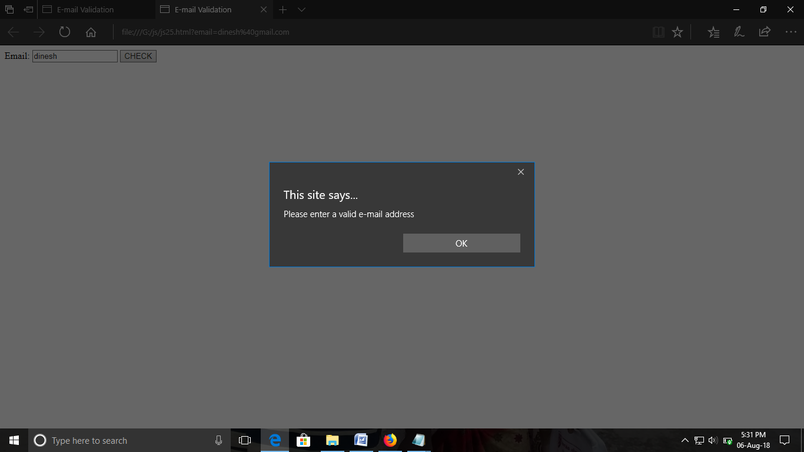

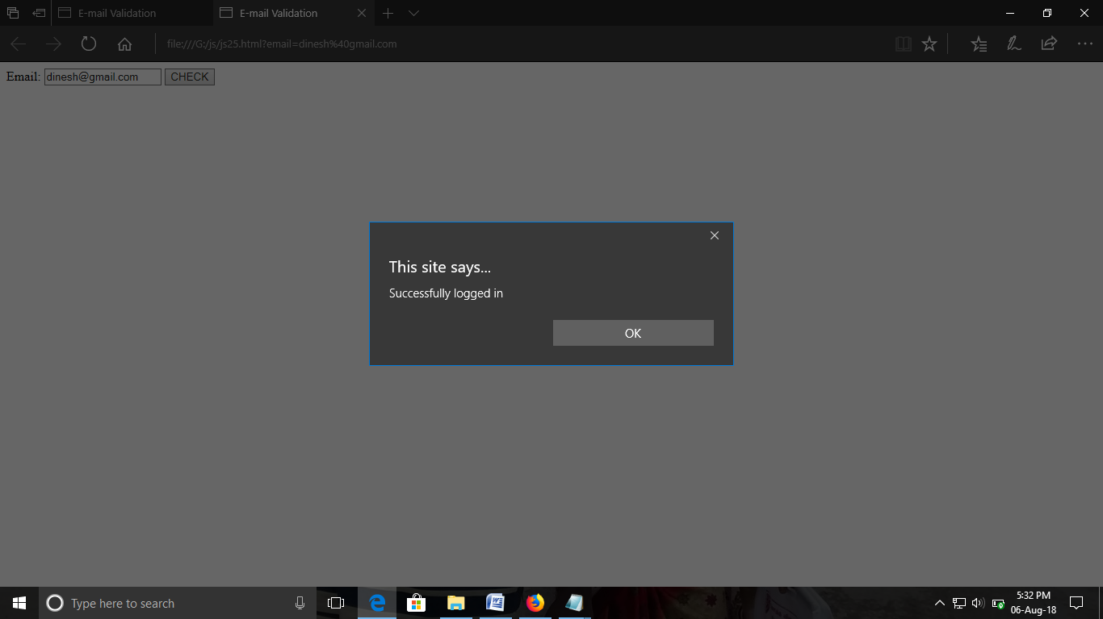

ExNo:26 //VALIDATE WEB FORM

PROGRAM:

<html>

<head>

<title>Form validation</title>

</head>

<body>

<form name="myForm" >

Name:<input type="text" name="name"><br><br>

Email: <input type="text" name="email"><br><br>

Address:<textarea rows="4" cols="50" name="comment" form="usrform">

Enter text here...</textarea>

</form>

<button onclick="valid()" >Register</button>

<script>

function valid(){

var x=document.forms["myForm"]["name"].value;

var y = document.forms["myForm"]["email"].value;

var atpos = y.indexOf("@");

var dotpos = y.lastIndexOf(".");

if (atpos<1 || dotpos<atpos+2 || dotpos+2>=y.length || x =="") {

alert("Give Input Value");}

else{

alert("Registred Successfully");}

}

</script>

</body>

</html>

OUTPUT:

